**A review of barriers and challenges of electric vehicles in India and vehicle-to-grid optimization**

Dr. Sundeep Singh Sainia, Harsh Raj Singha, Preet Mongaa, Moksh Guptaa, Km. Ayushia, Agamjyot Singh Maana

aDepartment of computer science engineering Chandigarh University NH05, Chandigarh-Ludhiana highway, Gharuan, Mohali, Punjab, India, 140413

**Abstract**

***Electric vehicles offer a significant alternative to traditional automobiles that use petrol and diesel as fuel. Instead of burning fossil fuel, electric energy from a battery is used to power the vehicle’s motor. In India, a country that is the fourth largest greenhouse emitter in the world, with 7.08% of all the emissions, and has some of the most populated cities, there is a growing concern about the population of the environment. As a result, people and governments are increasingly turning to cleaner sources of energy, with electric vehicles being a major focus. In India’s transportation sector, road transport is a primary contributor to carbon dioxide emission, accounting for 94.5% of the estimated 258.10 Tg of CO2 emitted from the sector between 2000 and 2004. This has led to increased research into electric vehicles and their components, with batteries being their critical components. This review paper aims to determine which of the presently available battery technologies is more efficient and advanced.***

# **I. INTRODUCTION**

**1.1 Why Do We Need To Switch To EVs?**

Greenhouse gas emissions are increasing day by day and this is the primary cause of the depletion of our precious bodyguard of UV rays. Major contributors to GreenHouse gas emissions are the fossil fuels that we burn for our daily usage such as in thermal power plants, automobiles, industrial applications, and many more. But among this hefty amount of contribution is of automobiles we use daily. That’s why there is a need to shift to EVs.

EVs will help in countering the growth of greenhouse and will in return help in protecting the environment. EVs are vehicles that run on electricity. As there is no use of fossil fuels, they are sustainable for our environment. Electric Vehicles can be used in various sectors such as public transport, goods transportation vehicles, and also the private sector.In India, the number of electric vehicles is increasing but at a slower pace. As per the Ministry of Heavy Industries, there are only 13,34,385 Electric Vehicles and 27,81,69,631 non-electric vehicles in India posted on 19 July 2022 by PIB Delhi. This is a very low number and there is an extreme need to switch to EVs.

**1.2 Battery - Primary Component of EV:**

Electric vehicles work on electricity and that needs to be stored somewhere which is called a battery. But currently, there are many problems associated with batteries, making EVs non-reliable for human beings. Different types of batteries are present in the market but each battery has a different drawback of its own making it difficult for a consumer to choose which to leave and which to buy. Moreover, the charging time and capacity of a battery also play a vital role in choosing a more reliable battery.

So we analyzed different types of batteries measuring various parameters for each battery. We observed that some of the major batteries that come in the market are Lead acid, Nickel Cadmium batteries, Nickel-metal Hydride batteries, Li-ion(cobalt) batteries, Li-ion(manganese) batteries, etc. There are many problems existing in batteries and we analyzed different batteries with different parameters to conclude which one is best for a consumer.Under Phase-1 of the FAME-India Scheme, the Ministry of Heavy Industries has sanctioned 520 EV Charging stations, of which 479 charging stations have been installed until 1st July 2022. ( For Eg 48 charging stations have been installed in Chandigarh,94 in Delhi,49 in Rajasthan, etc.) But we observe that the number of charging stations is very less in a vastly populated country like India.

**1.3. Benefits of EV:**

The success of electric vehicles is heavily reliant on advancements in battery technology, as EVs rely on batteries as their primary power source. Battery research is essential for improving EVs' performance, range, and affordability by developing more,longer-lasting, and faster-charging batteries that can make EVs more appealing to consumers.

**Environmental benefits:** One of the main advantages of EVs is their reduced environmental impacts compared to gasoline-powered vehicles. However, the manufacturing and disposal of EV batteries can still have negative environmental effects. Battery research aims to develop batteries that are more environmentally sustainable, with a reduction of carbon footprints and improved recycling methods.

**Energy storage:** Advances in battery technology can help make energy storage more efficient and

cost-effective, which can help to promote the use of renewable energy sources. High energy density batteries must be used which can store energy in lesser volume and less weight.

**Economic benefits:** The market of EV batteries is expected to grow significantly in the coming years, which could have significant economic benefits for countries that are leaders in battery technology. Research on EV batteries can be commercialized and exported, creating jobs and economic growth.

**II. LITERATURE REVIEW**

**2.1 Review of the literature:**

EV batteries have a long history. The batteries we use today and advancements in the batteries have been a collaborative effort of various scientists for many years. Following are the findings of scientists during their respective periods.

**Table 1:Discovery of different researcher**

|  |  |  |
| --- | --- | --- |
| **S.No** | **Scientist(s)** | **Discoveries** |
| 1 | Gaston Plante | In 1859 Gaston Plante discovered rechargeable lead-acid batteries. |
| 2 | Camille Faure | In 1881 Camille Faure discovered how to manufacture lead-acid batteries. |
| 3 | Neill Weber and JT Kumme | In 1967 they developed a sodium-sulfur battery while working at Ford.: |
| 4 | Exxon | In 1976 Exxon introduced lithium-titanium batteries but they were unable to stop them from exploding. |
| 5 | John Goodenough | In 1980 John Goodenough invented a lithium-cobalt-oxygen battery which is one of the basis of today’s lithium-ion technology. |
| 6 | Dr. Yoshino | Invented and patented the world’s first lithium-ion battery. He had about 60 patents on lithium ion during his career. |

# 

# **2.2 Period Of Evolution**

# With the exponential increase in demand for EVs, technology is also remodeling day by day. There are now many technologies available that are increasing the efficiency of EVs, including regenerative braking systems, smart power management through AI, and more. Batteries, which are a crucial component of EVs, have also undergone significant developments since the discovery of electric charge in the late 600 BC.

# These advances have led to smaller, lighter, and more efficient batteries that are helping to extend the range and reduce the charging times of EVs. In 1800 when Alessandro Volta invented the ‘Voltaic pile, which consists of alternating disks of copper and zinc separated by brine-soaked cloth no one ever thought that one day we could store electrical energy in small boxes. In 1982 when Nokia introduced the 10 kg smartphone no one had ever thought that one day (in 2022) a sports car (tesla model y) can fully run on batteries and can compete with cars with turbochargers. In 1991 Sony introduced Li-Ion batteries for the handheld camera but today in 2023 every electrical device which runs on battery uses a Li-ion battery as its primary power source. The prediction table shows that by 2025 electric vehicles will account for 25% of the total car market. By itself, by 2030 Li-ion batteries will have a $100bn market. From Voltaic plate(1800) to rechargeable lead-acid battery(1859)to iron-nickel battery(1902) to sodium-sulfur battery(1967) to lithium-cobalt-oxygen battery(1980) to sony Li-ion(1982) we have done a lot of effort to store electrical energy but in last Li-ion has proven its might in storing electrical energy. With high charge density and low maintenance, Li-ion has proved competent in many ways.

# .

# **2.3 Batteries Existing in the Market**

In EVs the major focus is on green energy, there are numerous types of batteries in the EV sector such as Lead Acid, NiCd, NiMh, Li-ion(Cobalt), and Li-ion(Manganese). The major parameters that we took into account while figuring out which battery to be used to have a maximum specific energy density, good cycle life, least charging time, low charging temperatures, and less maintenance requirement.

Following is the comparison between different types of batteries existing in the market

.

**Table 4:** Comparison of different batteries

|  |  |  |  |  |  |
| --- | --- | --- | --- | --- | --- |
| **Specification**  [1] | **Lead Acid** | **NiCd** | **NiMh** | **Li-ion**  **(Cobalt)** | **Li-ion**  **(Mangane-se)** |
| **Specific Energy Density** | 30-50 | 45-80 | 0-120 | 150-190 | 100-135 |
| **Cycle life** | 200-300 | 1000 | 300-500 | 500-1000 | 500-1000 |
| **Charging Time**[2] | 8-16hr | 1hr | 2-4hr | 2-4hr | 1 hr or less |
| **Charging Temperat-ure(c)** | -20 to 50 | 0 to 45 | 0 to 45 | 0 to 45 | 0 to 45 |
| **Maintenance**  **Requirement** | 3-6 months | 30-60 days | 60 to 90  days | Not Required | Not Required |
| **In use since** | the Late 1800s | 1950 | 1990 | 1991 | 1996 |

As we can see in **table 4** specific charge density is good in Li-Ion(Cobalt) batteries, the cycle life of NiCd batteries is maximum and Li-Ion(Manganese) has the least charging time among all the batteries. Lead Acid is having low charging temperatures. A very crucial feature is that Li-Ion batteries don’t require regular maintenance or changing of chemical components to keep them working.

After comparing the batteries, now we compared the existing EV models which are using different types of batteries

and technologies. Following is the table showing the comparison:

**Table 5:** Comparison of different EV models in the market

|  |  |  |  |  |  |  |
| --- | --- | --- | --- | --- | --- | --- |
| **S.No**  [3] | **Model name** | **Type of battery** | **Charging Time**  **(in hrs)** | **Life cycle**  **(in Kms)** | **Technology used** | **Range (in Kms)** |
| **1**[4] | **Tesla Model S** | Lithium -ion | 0.25 | 300,000 | 444 Panasonic NCR18650B cells in 6s74p config. | 647 |
| **2** | **Nissan Leaf** | Lithium -ion | 0.66(80% charge) | 160,000 | 1670Wh module with 8 metal cells of 3.65V each | 417 |
| **3** | **Ford Mustang Mach-E** | NCM batteries/LFP batteries | 0.75 | 240,000 | Standard range 70.0kWh battery | 475 |
| **4** | **Hyundai Kona** | Lithium -ion polymer | 1.25 | 200,000 | Standard/Long range battery pack with 64kWh/77.4kWh with regenerative braking | 484 |
| **5** | **Audi e-tron** | Lithium -ion | 0.5 | 240,000 | 83.7kWh energy with 33 cell modules each comprising of 12 pouch cells. | 329 |

As we can see in **Table 5**, most of the car companies are using Lithium-Ion and according to the technology of the type of charger they use and the current/voltage specifications, the charging times of the above-mentioned EVs are different. Due to this, the range of EVs and the life cycle of batteries also varies. In the further part, we will do a complete analysis of EVs and their parameters.

**2.4 Parameters of Different Batteries**

After studying multiple research papers, a critical analysis must be carried out to get to a conclusion that what type of battery is best in every aspect. Necessary features that an EV must hold are a better life cycle of different batteries, market share of batteries, demand per year, charging time of batteries, and range of batteries.

As we can see in **Table 5**, all the car companies are using Li-Ion batteries with different configurations. So, this shows that among all the batteries available in the market Li-Ion is the best, and the following is the data to justify the statement.

**1. The high energy density of Li-Ion Batteries:**

Batteries are mainly compared on the basis of two densities. Firstly gravimetric and second volumetric density. Specific energy density or gravimetric energy density is the measure of the energy of a battery with respect to the weight of the battery whereas the volumetric energy density of the battery is defined as the energy stored with respect to volume.

High energy density means storing high energy in a lesser volume and having a lighter weight. After studying various batteries and their energy densities, the graph has been plotted below.

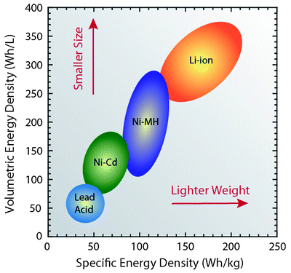

**Fig 1.** Specific Energy Density Vs Volumetric Energy Density[5]

As we can see in **Fig 1,** a graph has been plotted between specific energy density(Wh/Kg) along the x-axis and volumetric energy density(Wh/L) along the y-axis. Li-Ion batteries have a higher energy density which means they can store a higher amount of energy in smaller sizes and will attain lighter weight which is a vital attribute to be considered while manufacturing an EV.

**2. The good life cycle of Li-Ion**[6]**:**

Another factor that comes into a customer’s mind is the life cycle of batteries, these must be future safe and there must be no need to replace them in a shorter span of life. Various parameters comparison has been plotted below comparing different batteries.

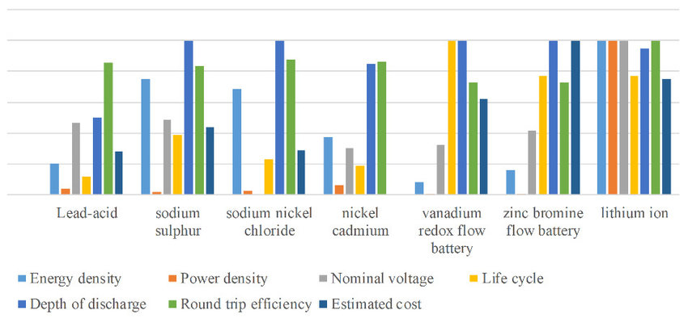

**Fig 2**. Various parameters comparison between different batteries[7]

According to the histogram in **Fig 2**, Li-Ion has the second highest life cycle after vanadium redox flow battery but in the overall comparison of various aspects such as energy density, power density, nominal voltage, depth of discharge, round trip efficiency and estimated cost, Li-Ion is the best. Li-Ion has a good life cycle of 2000-2500 life cycles which ensures future safety and there is no need to replace the batteries for 10-15 years. This reduces the fear of customers.

**3. High Demand for Li-Ion:**

Another question that comes into the mind of the consumer is that the EV he might purchase today must hold a good price value in the future also if he wants to replace the car. The following graph shows the market capture of Li-Ion in the upcoming years.

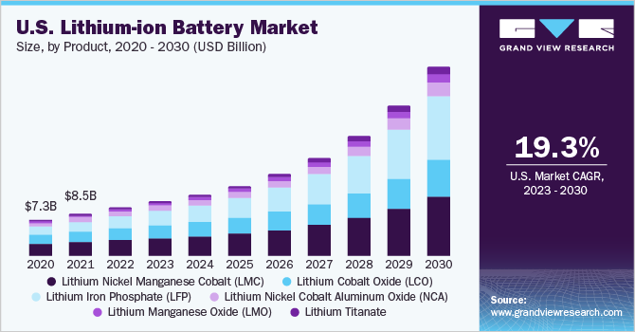

**Fig 3**. Growth of the lithium-ion battery market

At present, the global lithium-ion battery market is valued at US$ 59.8 Billion and is projected to grow to US$ 307.8 Billion by 2032 which shows that the demand for Li-Ion is increasing significantly and it is reliable in future use also. The growth prediction of lithium-ion batteries is about 19.3% from 2023 to 2030 as shown in **Fig 3**.

As we talked about the key features that Li-Ion holds but it also has some drawbacks such as high initial life cycle costing and high replacement costs of batteries. Let’s discuss these drawbacks with factual data.

**High Initial Life-Cycle Costing:**[8]

Nowadays, automobiles running on various fuels are available in the market and each fuel has its own key features and drawbacks. Initial life cycle costing is another factor that should be kept in mind while purchasing an EV which is how much each life cycle of battery costs with respect to operating time(KM).

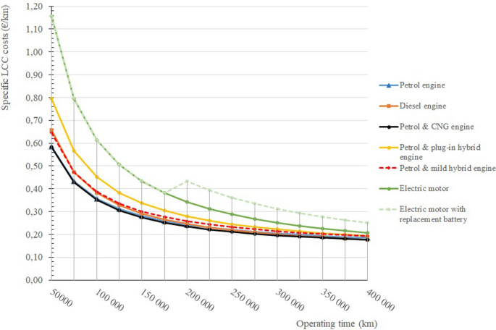

**Fig 4**  Life-Cycle Costing VS Operating Time

As seen in **Fig 4**, after plotting the graph between LCC and operating time(in KMS), we can see that the life cycle cost of an electric motor with replacement batteries used in electric vehicles is slightly on the higher side than other fuel engines. This is one of the major reasons why people resist switching to EVs.

**High Replacement Cost of Batteries:**

In non-electric vehicles, there are fewer chances of engine failure and replacing the engines. But in EVs after years of discharging and charging, there is a need to replace the batteries and this is another issue with electric vehicles.

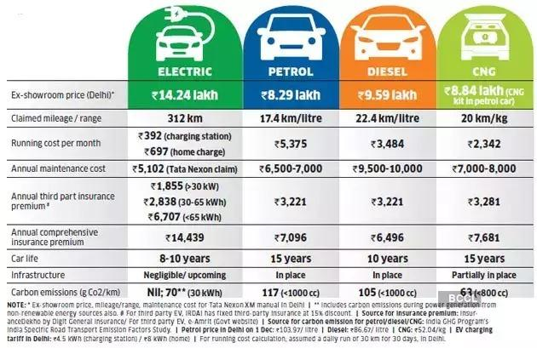

**Fig 5.** Comparison between cars with different power sources

In **Fig 5**, we can see that electric vehicles are better in running cost per month, and annual maintenance cost but the issue arises in the case of high initial cost and short life span of batteries. Due to the fear of replacing batteries and the cost of replacing batteries is high, people do not switch to EVs due to the short life span of about 10-15 years.

**CONCLUSION**

Around[16] 1832 when Robert Anderson first built a crude electric vehicle in 2023 when the electric vehicle market had grown up toUSD 3.21 Billion (2022). EVs have grown exponentially but not up to their full potential. Despite facing many challenges and technological hurdles we have come a long way.

With the changing world order and new technologies, we have made exponential progress in the field of batteries used in EVs. From nickel to lead acid and from nickel-cadmium to nickel hydride we have improved the efficiency in each step. Currently, the best solution according to our findings for EV battery manufacturing is the Li-ion. It has solved many problems like charge density, range anxiety, heating effect, and fast charging. Much more research is also going on to improve this existing technology like the removal of nickel and the introduction of liquid cooling charging cables. With the forthcoming technology, the efficiency and potential to deliver more power will increase exponentially.

**5.2 FUTURE SCOPE**

Batteries play a crucial role in reducing carbon emissions, mitigating the greenhouse effect, and decreasing our reliance on fossil fuels such as petrol and diesel. Currently, Lithium-ion batteries are the primary technology used in the world. However, many innovative EV charging methods are expected to emerge in the future EV market.

* **Carbon Nanotube Electrodes:**[9] Nawa Technologies has developed and obtained a patent for a Carbon Nanotube Electrode that can revolutionize the EV charging process. This innovative electrode is extremely fast, allowing for a charging time of just five minutes to achieve 80% battery capacity.
* **Cobalt-free battery:**[10] It is being developed by the University of Texas, which employs a cathode that does not contain cobalt. Instead, the cathode consists of 89% nickel, as well as aluminum and manganese, in a lithium-ion battery.
* **Silicon Anode Batteries:** [11]To overcome the instability of silicon in lithium-ion batteries, a University of Finland researcher has discovered a technique for developing a hybrid anode. This anode incorporates mesoporous silicon microparticles and carbon nanotubes to enhance stability and performance.
* **Power by Wi-Fi:**[12] There is a groundbreaking concept being discussed regarding the possibility of recharging an EV wirelessly through Wi-Fi while it's in motion, thereby eliminating the need for plugging in a charger. This idea involves using a radio wave harvesting antenna developed by researchers, which can harness electromagnetic waves to recharge an EV.
* **Zinc-Air Batteries:**[13] The University of Sydney researchers have discovered a technique for producing cost-effective zinc-air batteries, which are more affordable than current zinc battery prices. These batteries are also safer, as they are not flammable, and offer faster charging times of up to 20 times, and longer-lasting performance than lithium-ion batteries.

**References:**

[1] E. F. I. Raj, “Review of Different Types of Batteries Used in Electric Vehicles and Their Charging Methods,” no. 12, pp. 110–113, 2018.

[2] A. Tomaszewska *et al.*, “Lithium-ion battery fast charging: A review,” *eTransportation*, vol. 1, p. 100011, 2019, doi: 10.1016/j.etran.2019.100011.

[3] C. Iclodean, B. Varga, N. Burnete, D. Cimerdean, and B. Jurchiş, “Comparison of Different Battery Types for Electric Vehicles,” *IOP Conf. Ser. Mater. Sci. Eng.*, vol. 252, no. 1, 2017, doi: 10.1088/1757-899X/252/1/012058.

[4] M. Kuipers, F. Hust, S. Meier, and D. U. Sauer, “An in-depth View into the Tesla Model S Module Part Two: Module Characterization and Comparison to Other State of the Art EV Battery Systems,” no. 18650, p. 2, 2017, [Online]. Available: files/6905/Kuipers et al. - An in-depth View into the Tesla Model S Module Par.pdf

[5] T. Bashir *et al.*, “A review of the energy storage aspects of chemical elements for lithium-ion based batteries,” *Energy Mater.*, vol. 1, no. 2, p. 100019, 2022, doi: 10.20517/energymater.2021.20.

[6] J. Tian, R. Xiong, and W. Shen, “A review on state of health estimation for lithium ion batteries in photovoltaic systems,” *eTransportation*, vol. 2, p. 100028, 2019, doi: 10.1016/j.etran.2019.100028.

[7] S. Hussain, M. U. Ali, S. H. Nengroo, I. Khan, M. Ishfaq, and H. J. Kim, “Semiactive hybrid energy management system: A solution for electric wheelchairs,” *Electron.*, vol. 8, no. 3, 2019, doi: 10.3390/electronics8030345.

[8] L. Gaines, J. L. Sullivan, A. Burnham, and I. Belharouak, “Paper No. 11-3891 Life-Cycle Analysis for Lithium-Ion Battery Production and Recycling,” *90th Annu. Meet. Transp. Res. Board*, no. 11, pp. 1–8, 2011, [Online]. Available: https://www.researchgate.net/publication/265158823_Paper_No_11-3891_Life-Cycle_Analysis_for_Lithium-Ion_Battery_Production_and_Recycling

[9] H. T. Das *et al.*, “Recent Trends in Carbon Nanotube Electrodes for Flexible Supercapacitors: A Review of Smart Energy Storage Device Assembly and Performance,” *Chemosensors*, vol. 10, no. 6, 2022, doi: 10.3390/chemosensors10060223.

[10] L. Noerochim, S. Suwarno, N. H. Idris, and H. K. Dipojono, “Recent development of nickel-rich and cobalt-free cathode materials for lithium-ion batteries,” *Batteries*, vol. 7, no. 4, 2021, doi: 10.3390/batteries7040084.

[11] A. Casimir, H. Zhang, O. Ogoke, J. C. Amine, J. Lu, and G. Wu, “Silicon-based anodes for lithium-ion batteries: Effectiveness of materials synthesis and electrode preparation,” *Nano Energy*, vol. 27, pp. 359–376, 2016, doi: 10.1016/j.nanoen.2016.07.023.

[12] T. Wang, X. Liu, N. Jin, H. Tang, X. Yang, and M. Ali, “Wireless power transfer for battery powering system,” *Electron.*, vol. 7, no. 9, 2018, doi: 10.3390/electronics7090178.

[13] W. Shang *et al.*, “A zinc-air battery capable of working in anaerobic conditions and fast environmental energy harvesting,” *Cell Reports Phys. Sci.*, vol. 3, no. 6, 2022, doi: 10.1016/j.xcrp.2022.100904.

# 

# 

# 

# 